f = open("students.csv", 'r')

p = open("newStudent.csv", "w")

data = f.read()

m = []

table = []

sum = 0

a = data.split("\n")

a.pop()

for i in range(0, len(a)):

    table.append(a[i].split(","))

for l in range(1, len(table)):

    for j in range(1, len(table[0])):

        sum = sum+int(table[l][j])

    m.append(sum)

    sum = 0

for b in range(1, len(table)):

    table[b].append(m[b-1])

for h in range(0, len(table)):

    for n in range(0, len(table[h])):

        p.write(str(table[h][n]))

        p.write(",")

    p.write("\n")

p.close()

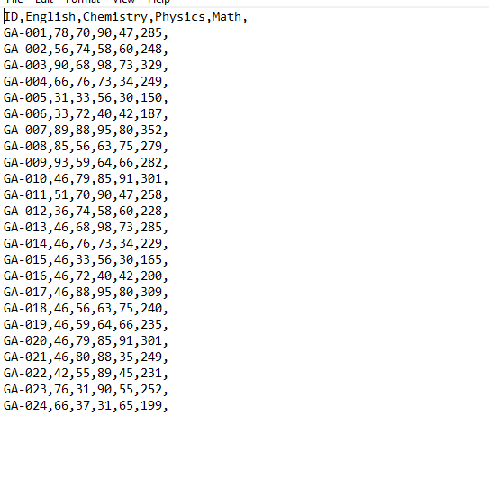

f = open("students.csv", 'r')

data = f.read()

m = []

table = []

sum = 0

a = data.split("\n")

a.pop()

for i in range(0, len(a)):

    table.append(a[i].split(","))

for l in range(1, len(table)):

    for j in range(1, len(table[0])):

        sum = sum+int(table[l][j])

    m.append(sum)

    sum = 0

print(m)

